
Final Project Report
ICT Lab

University Name: National University of Computing and Emerging Sciences
(FAST)
Department: Computer Science
Course: Introduction to Information and Communication Technology
Project Title: Wallpaper Gallery Web Application
Submitted By: 1) Muhammad Ahmad 25K-0587
2) Hasnain Ali 25K-0841
Submitted To: Sir Osama Tahir
Semester: Fall 2025
Date: December 1, 2025

Abstract
The Wallpaper Gallery Web Application is an interactive, user-friendly platform that allows users to browse, search, preview, and download HD wallpapers across multiple categories. The user can also upload their own wallpapers. It illustrates event handling, dynamic rendering, and DOM manipulation using HTML, CSS, and JavaScript.

1. Introduction
The goal of this project is to develop a dynamic Wallpaper Gallery with a variety of user capabilities, including uploading of the wallpapers by themselves, previewing, searching, and filtering of the wallpapers.

2. Objectives
- We created an interactive wallpaper gallery using HTML, CSS, and JavaScript.
- It allows dynamic interaction such as search, filter, preview, and download. The user can also upload wallpapers, which will appear on the screen
- Build multiple supporting pages like (Browse page, Categories page, Contact page, Privacy page, Terms page).

3. System Design
- System Overview:
The system uses HTML & CSS for structure and design, and JavaScript for dynamic rendering, event handling, and image processing.

- Input & Output:
Inputs include search queries, category filters, and uploaded images. Outputs include rendered wallpapers, modal previews, downloads, and feedback form confirmation.

4. Implementation
Language: HTML, CSS, JavaScript
IDE: VS Code
Runtime: Web Browser

- Key Features:
- Dynamic wallpaper rendering
- Search & category filters
- Upload wallpapers
- Preview modal
- Download feature
- Additional pages & feedback form

- Sample Code Snippet:
function showWallpapers(list) {
gallery.innerHTML = "";
list.forEach(w=>{
gallery.innerHTML += `
<div class="card">
<img src="${w.img}">
<div class="info">
<h3>${w.name}</h3>
<p>${w.cat}</p>
</div>
</div>
`;
});
}
5. Testing & Results
All major features including search, upload, preview, delete, filtering, and download were tested and function correctly.
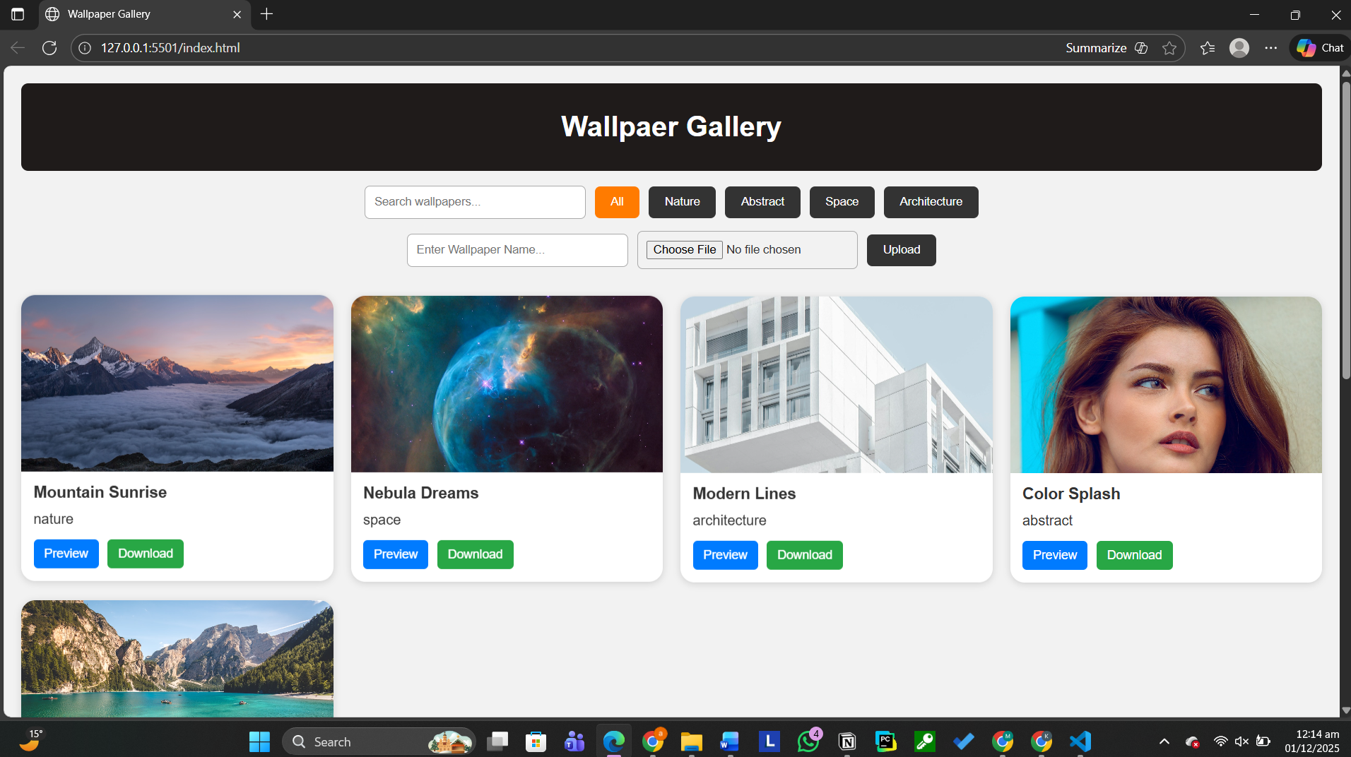
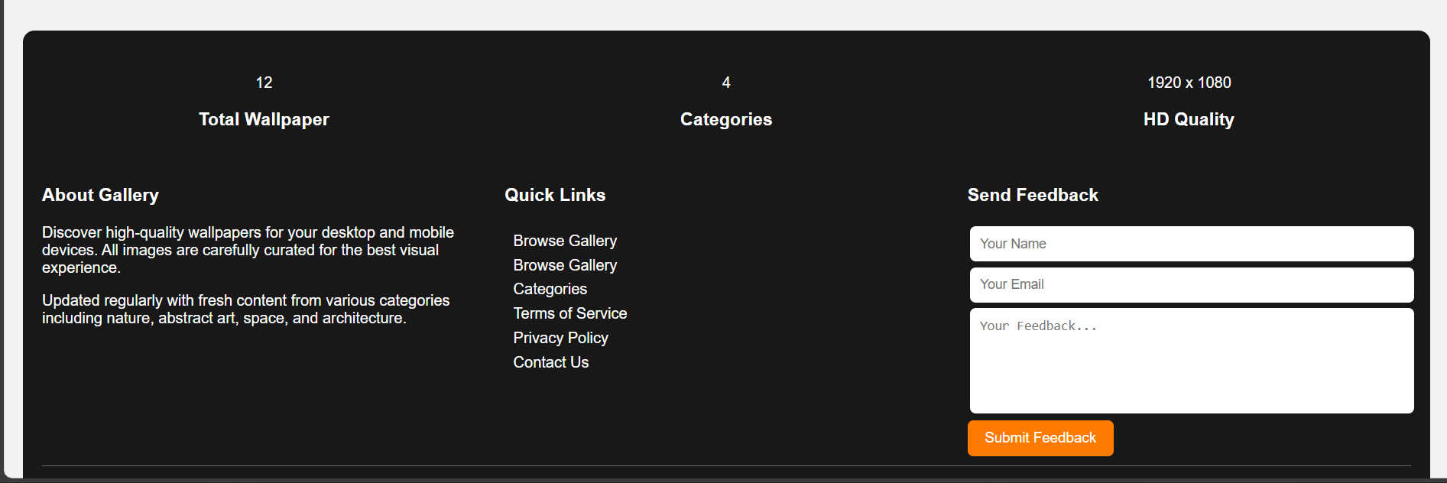
6. Conclusion, Limitations & References
Conclusion:
This project shows our web development skills, creativity and helps us to implement the skills we learned during our Semester.

Limitations:
- No backend storage right now
- Feedback is not saved permanently
- Uploaded wallpapers disappear after every refresh

Future Enhancements:
- Backend database
- User accounts
- Cloud storage
References:
- MDN Web Docs
- W3Schools

